**1. Dataviz Best Practices**

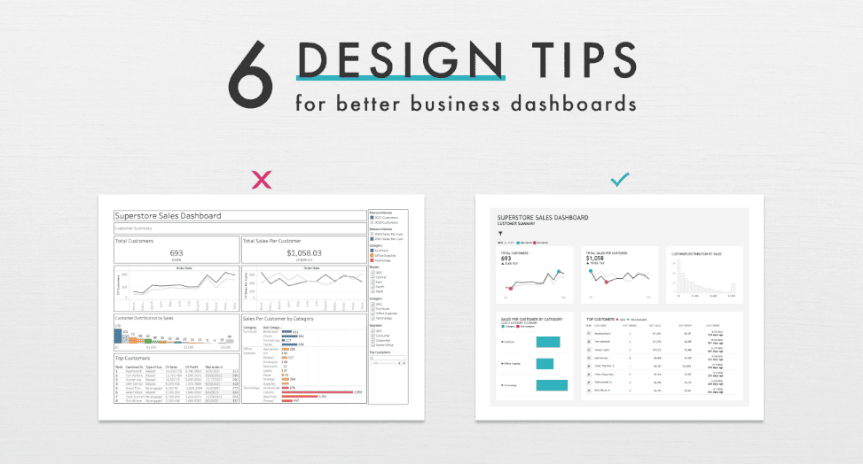

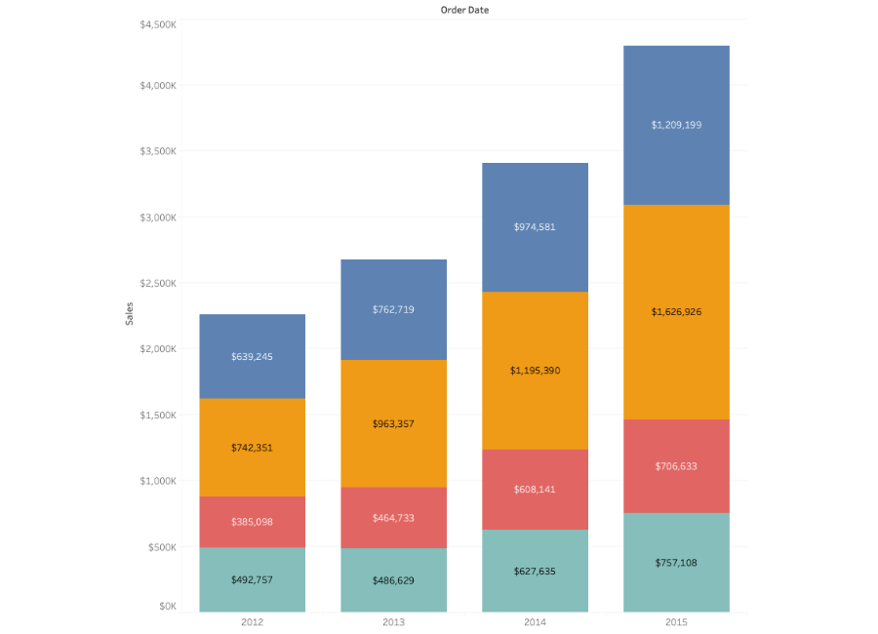

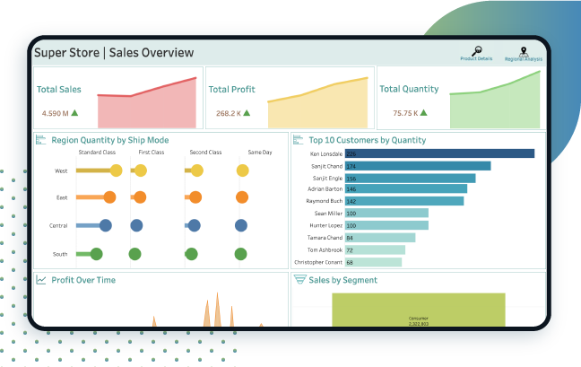

4

**Guidelines**

1. **Start with the simplest chart that answers the question.**  
   Choose bar or line before jumping to exotic visuals.
2. **Remove clutter.**  
   Avoid heavy borders, shadows, and decorative colors.
3. **Use color for meaning, not decoration.**  
   For example, use color to represent Category, Region, or Profit sign.
4. **Maintain consistent scales.**  
   If comparing values, axes should start at zero for bars.
5. **Label clearly and concisely.**  
   Use short titles like “Sales by Category”.

**2. Creating More Advanced Chart Types**

**A. Dual Axis Chart (Sales vs Profit)**

Useful when you want to compare two metrics with different scales.

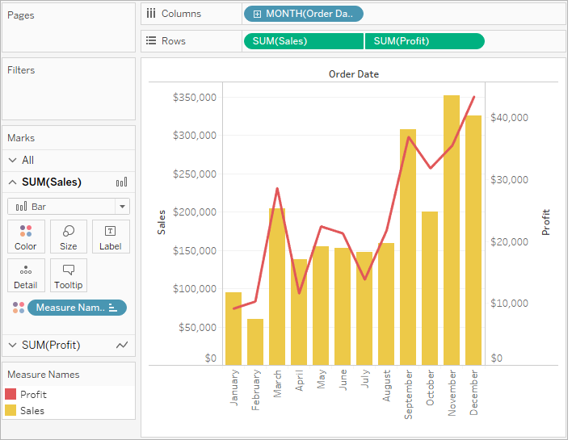

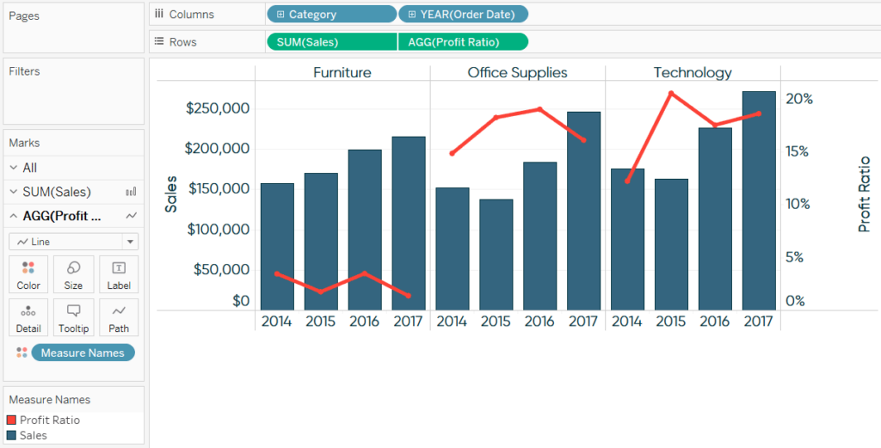

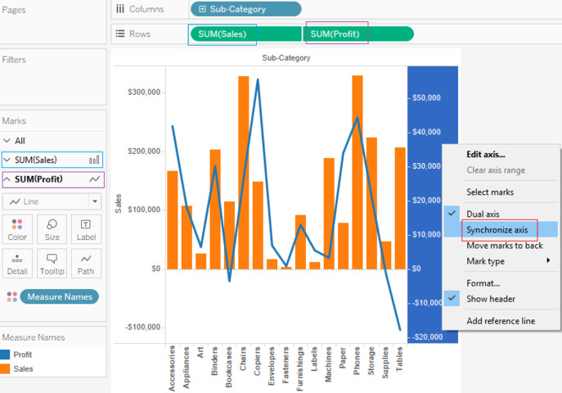

4

**Steps**

1. Drag **Order Date** to **Columns**.
2. Drag **Sales** and **Profit** to **Rows**.
3. Right click **Profit axis** and choose **Dual Axis**.
4. Right click axis again and choose **Synchronize Axis**.
5. Set one Marks type to **Bar** and another to **Line**.

Result: A combined Sales & Profit performance chart.

**B. Heat Map (Category vs Region by Sales)**

Highlights concentration levels.

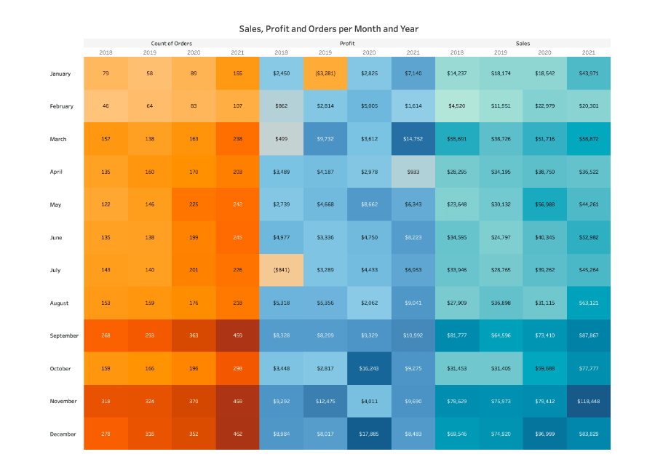

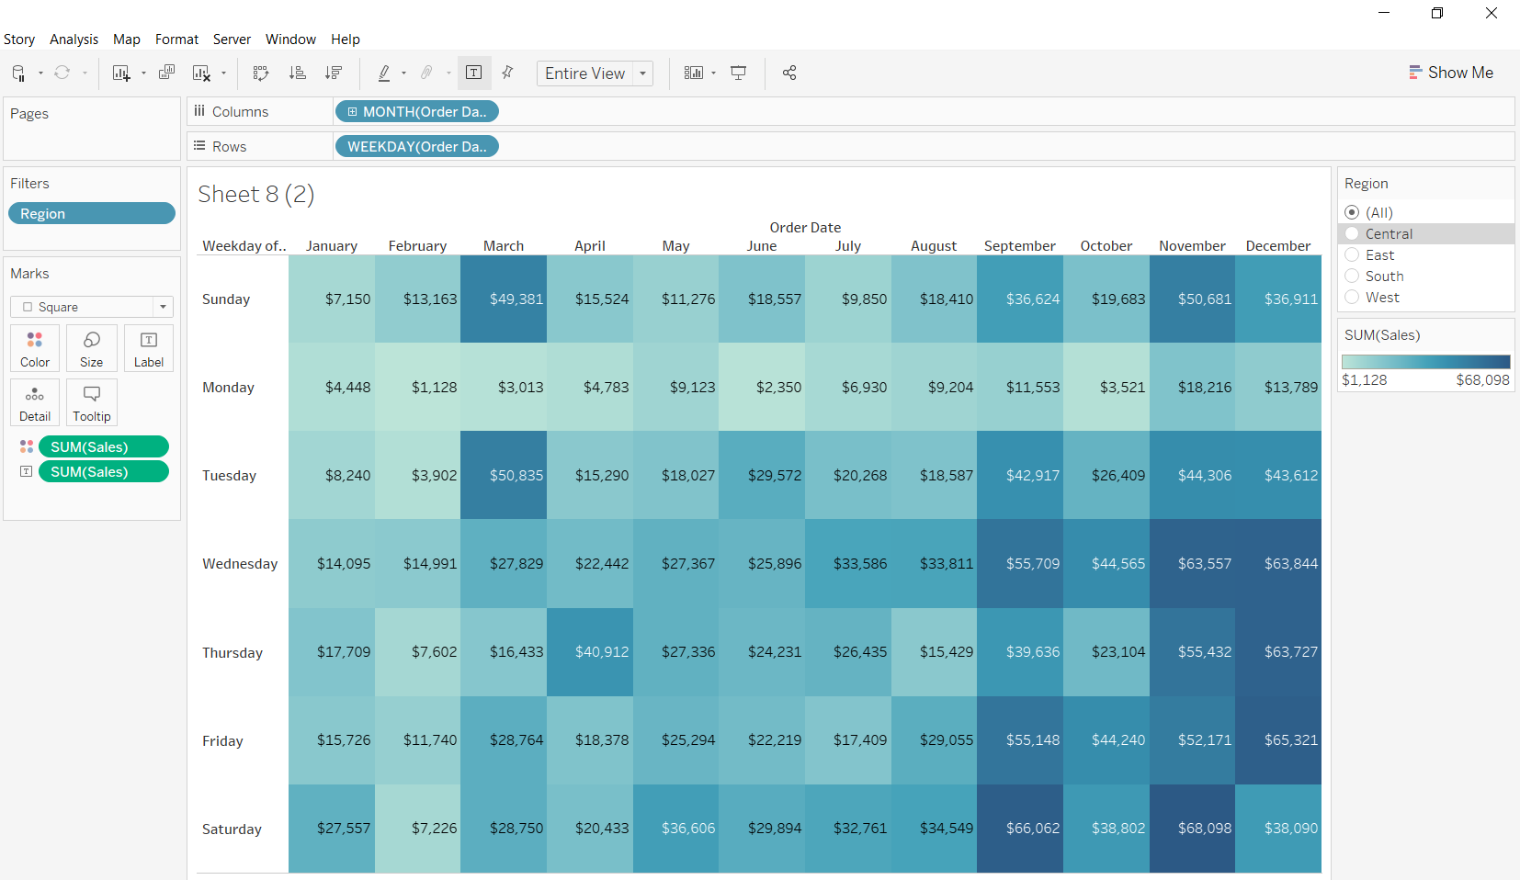

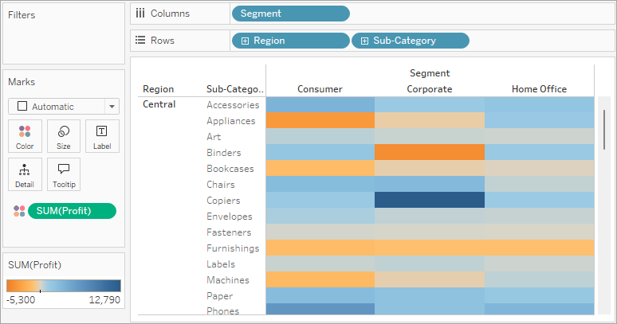

4

**Steps**

1. New worksheet.
2. Drag **Category** to **Rows**.
3. Drag **Region** to **Columns**.
4. Drag **Sales** to **Color**.
5. Change Marks type to **Square**.
6. Adjust color intensity to highlight contrast.

**C. Tree Map (Share of Sales by Sub-Category)**

Good for showing hierarchical proportions.

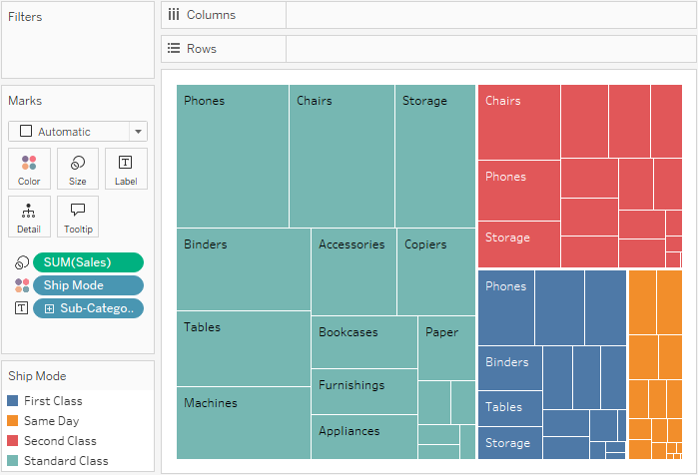

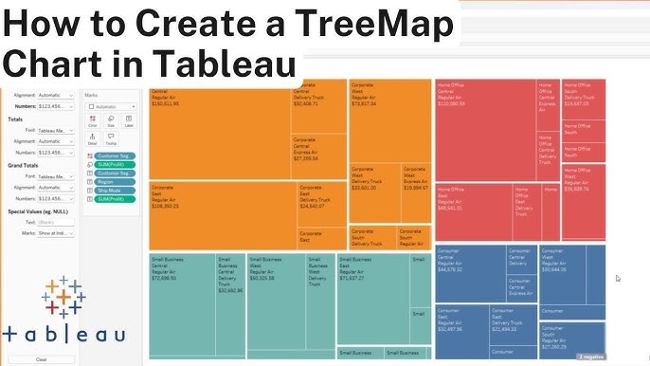



4

**Steps**

1. Drag **Sub-Category** to **Label**.
2. Drag **Sales** to **Size**.
3. Drag **Profit** to **Color** (optional).
4. Change Marks type to **Square** or use **Show Me → Treemap**.

Rectangles scale based on value size.

**D. Funnel Chart (Sales or order stages)**

Used for stages like pipeline conversions.

**Steps**

1. Create a bar chart sorted descending.
2. Edit axis width or use a calculation to scale bar width.
3. Use **Table Calculation → Percent of Total** if needed.

This reveals loss or drop in stages.

**3. Using Multiple Source Tables**

**A. Simple Join**

When tables share a key field.



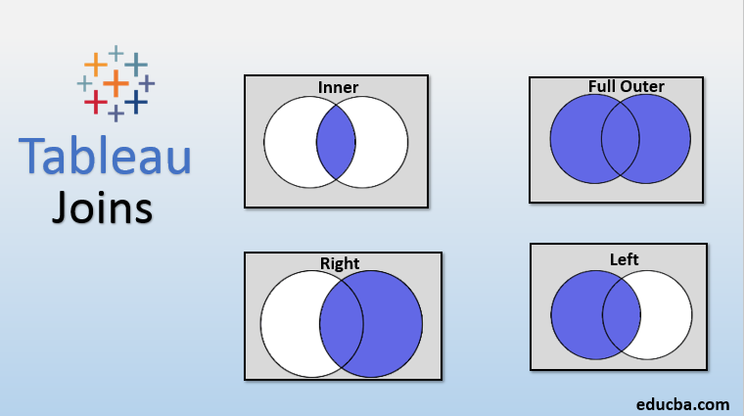

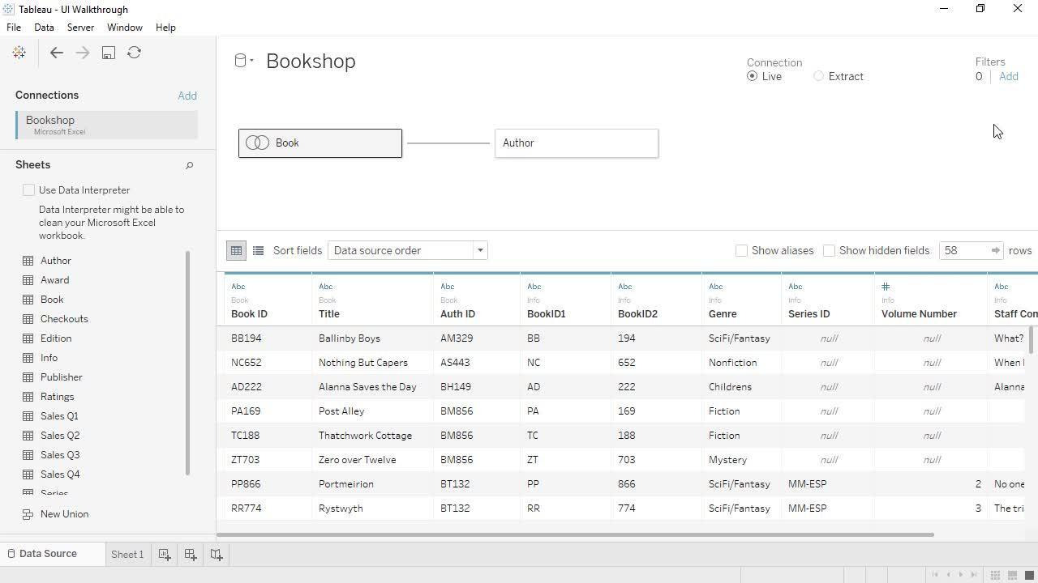

4

**Steps**

1. In **Data Source**, connect to table A.
2. Drag table B next to table A.
3. Tableau asks for Join condition.
4. Choose field (e.g., Order ID = Order ID).
5. Select join type:
   * Inner
   * Left
   * Right
   * Full

**Example**  
Join Orders and Returns table using Order ID.

**B. Relationship (Recommended in modern Tableau)**

Tableau treats tables independently and blends at query time.

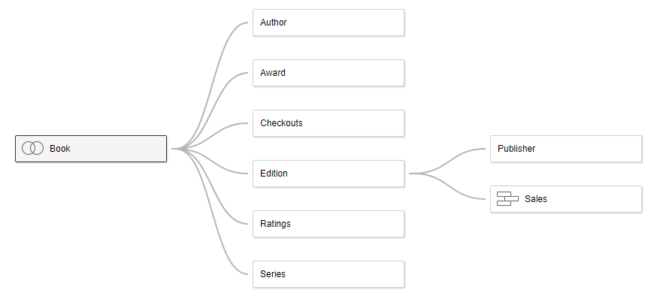

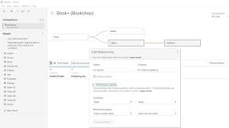

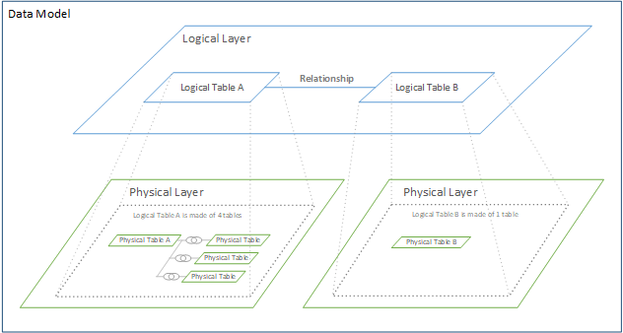

4

**Steps**

1. Drag second table near first in logical layer.
2. Tableau shows a noodle-style relationship link.
3. Set relationship fields (e.g., Customer ID).
4. Keep tables separate. Tableau will optimize performance.

**Benefits**

* Less duplicated data.
* Better aggregation.
* Fewer row explosions.

**C. Data Blending (Different data sources)**

Useful if tables cannot be joined directly.

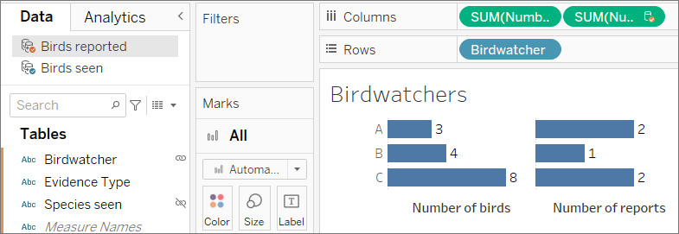

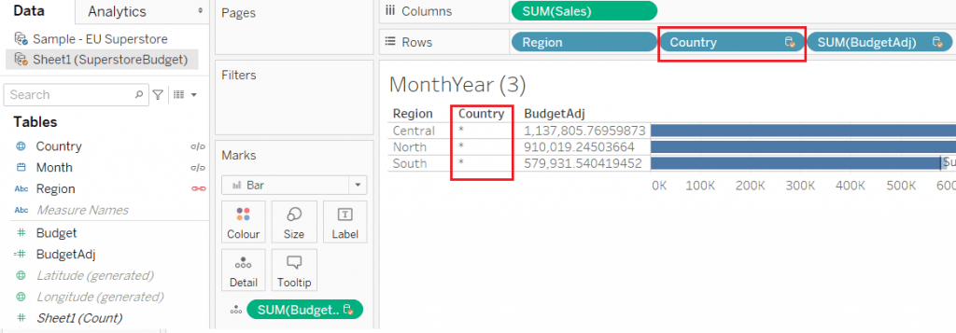

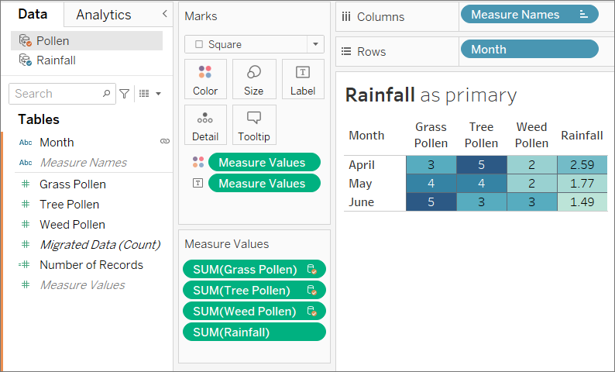

**Steps**

1. Connect to first source (Primary).
2. Connect to second source (Secondary).
3. Create worksheet.
4. Add a field from primary.
5. Add a matching field from secondary.
6. Tableau shows a link icon beside a dimension.
7. Enable link to blend.

**Example**  
Sales data from Excel + Target values from CSV.